Name:  Class: | ____________________________________  ________________ |  | Date:_________
 | Year 11 Essential Mathematics  / 42  8 %  Unit 2 Major Test 1 2018  Topic -Representing and Comparing Data
Total Time: | 55 minutes
Weighting: | 8%
Equipment: | To be provided by the student: Pen, pencil, ruler,1 double sided A4 page of notes, scientific calculator  Teacher will provide grid paper

Full working out must be shown to get full marks. Attempt all questions.

Question 1 6 marks

This dot plot shows the foot length of a group of students.
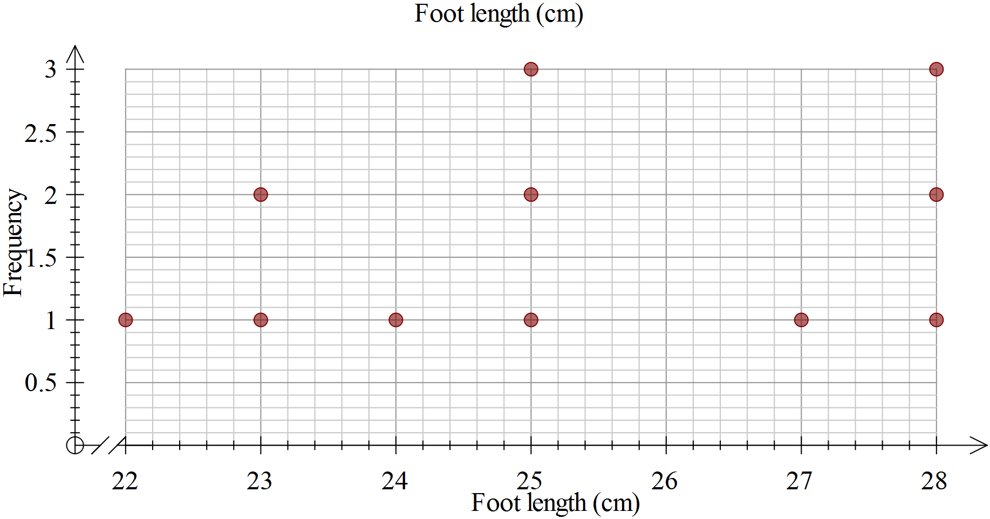
- Calculate the range of the scores, showing your working.

- Determine the mode.

- Determine the median.

- Calculate the mean, showing your working.

- Complete this sentence: For a student in this group, you would expect them to have a foot length of about ____cm.

Question 2 11 marks-1, 5 ,2 , 3

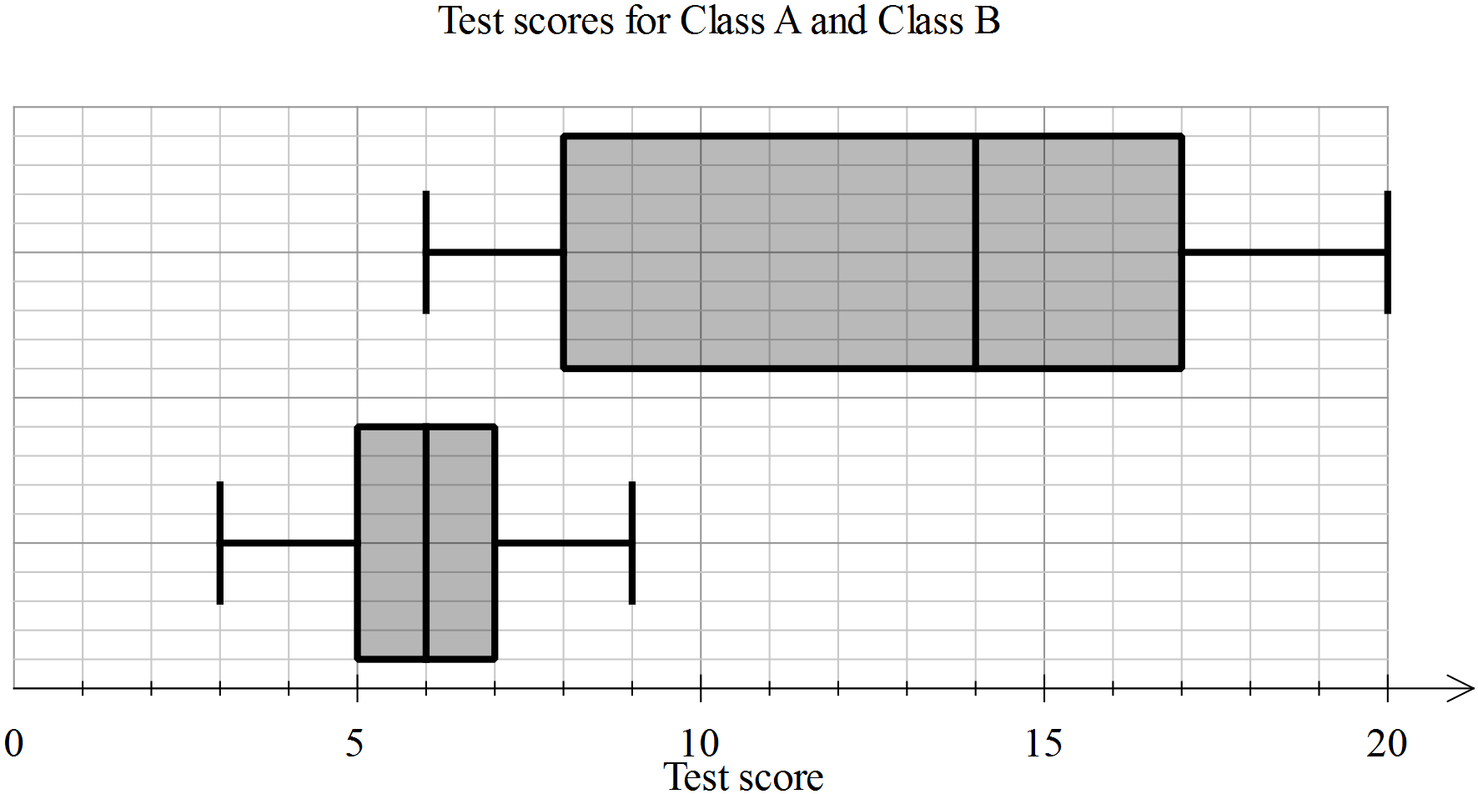
- Eric is in Class A, he scored 5 on the test. Label the two box plots with their class names.
- Use the table below to enter the appropriate values for each of the plots.
Statistic | Class A | Class B
Minimum
First quartile
Median
Third quartile
Maximum

- Calculate the range and interquartile range for each class, showing the working, in the table below.

Statistic | Class A | Class B
Range
Interquartile range

- In each of the statements below, write A and B as appropriate to make the statement true.
- Class ___ has a much greater range than Class ___
- The minimum for Class ___ is the same as the median for Class ___
- For Class ___, the second and third quartiles are the same width, whereas for Class ___, the second quartile is much greater than the third quartile

Question 3 6 marks ( 2, 2, 1, 1)

Data Set 3 consists of data on the number of text messages sent in one month for 100 teenage girls who have a cell phone. Data Set 4 consists of data on the number of text messages sent in one month for 100 teenage boys who have a cell phone. Histograms of the two data sets are shown below.

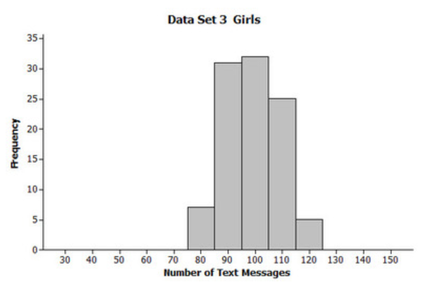 | 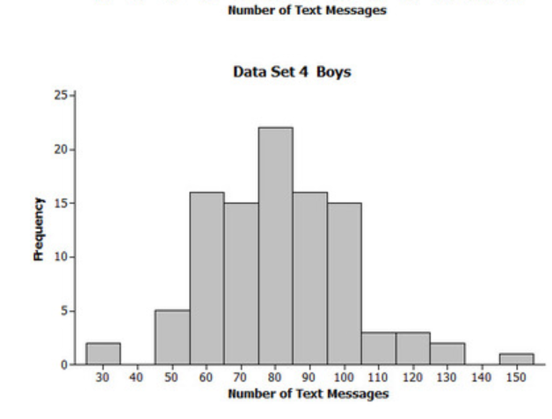
- Describe the data distribution of number of text messages for the girls (Data Set 3). Be sure to comment on symmetry, skewness and bimodality and unimodality, where applicable.

- Are Data Set 3 and Data Set 4 centred in about the same place? If not, which one has the greater centre?

- Which of Data Set 3 and Data Set 4 has greater spread? Explain.

- On average, did the girls (Data Set 3) or the boys (Data Set 4) send more text messages? Explain

Question 4 6 marks (3, 1, 1, 1)

Mum and Lucy were having an argument about the number of hours she spends on Facebook each night. They decided to record how many hours she spent on Facebook for one week. The results are shown below.

Day | Mon | Tues | Wed | Thurs | Fri | Sat | Sun
Hours on Facebook | 4 | 2 | 2 | 1 | 6 | 4 | 8

- Find the mode, median and mean for this data.

- Which of these measures could Mum use to demonstrate that Lucy spends too long on
Facebook? Explain your reasoning.

- Which of these measures could Lucy use to show that she doesn’t spend too much time on Facebook? Explain your reasoning.

Question 5 3 marks

Two classes are marked on the same tests.
Class P has a mean of 65% and standard deviation of 5.
Class Q has a mean of 50% and standard deviation of 15.
- Write a statement comparing the scores of the two classes, that is, who had the better scores?

- Write a statement comparing the spread of the scores for the two classes.

- Which class would you expect to have the highest score? Explain.

Question 6 10 marks (5, 3, 2)

Peter and Kingi are arguing about which local rugby league team is the best. The points scored by their favourite teams in each match over the previous season are listed here:

Lions: 20, 10, 40, 12, 17, 20, 22, 20, 34, 19, 36, 18, 24, 12, 38, 24, 34, 36, 32, 22, 6, 7, 38, 18

Cougars: 14, 18, 24, 39, 14, 4, 4, 14, 10, 13, 28, 22, 16, 18, 18, 12, 18, 28, 21, 6, 10, 18, 36, 12

- What is the best graph to use to show this data? Construct this graph

- Which is the better team based on this data? Justify your answer using mathematical terminology about distribution shape and or the measures of central tendency.

- What additional data might you need to know in order to decide which is the better team?

END OF TEST

